Berkshire Bugle
January 2023
Happy New Year to one and all. We hope you enjoyed a wonderful Christmas and have managed reasonable health and been able to keep warm, the latter being quite a challenge in the last few days!! I have to say I prefer the cold to the rain as I have had too much of it leaking into to my old place!
Unfortunately, there has been a lot of sadness in the Fellowship, both at the end of last year and the beginning of this.
We were very sad to learn of the death of June Finch in December. She and husband Bill were well known faces in the Fellowship as, for many years, they ran the flagship Lantern Hotel in Worthing. There were several permanent residents there and members from all over the country enjoyed super holidays. It was such a shame when they retired and The Lantern was never the same without them. They always had a cheery smile for everyone and provided great food and entertainment. Both continued to be active in the Worthing Branch and June continued after Bill’s death a few years ago. I chatted with her at their annual lunch in October last year. We can only reflect on how much she did for the Fellowship and remember some happy times.
From BPF website……..Joe Fisher passed away in November 2022
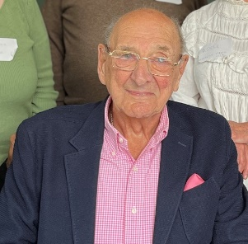
“Patron and dear friend of the British Polio Fellowship, Joseph Fisher has died aged 100, his family confirmed.

Joe dedicated his life to helping polio survivors and in honour of his service to charity and the British Polio Fellowship, he received an MBE from the Queen in 2015.

While serving the Army in Burma, Joe contracted polio aged 23, and had to return to England to recover. He had 95% disability and paralysis down one side of his body. Joe was left in poor health and struggled to earn a living in post-war London. But he was always sure of one thing – that people with polio can and should work.

When living in London, Joe began to attend meetings of the British Polio Fellowship (formally known as the Infantile Paralysis Fellowship) but was determined to do something to help polio survivors in his hometown. When he returned to Newcastle, he set up a branch in the North East and began helping to rebuild members’ self-esteem and find employment.
In 1954, with a large donation from RAG week at Newcastle University, Joe purchased a house in Jesmond, Newcastle upon Tyne and converted it into a hostel and training centre for 15-20 polio survivors to live and work.
Joe leaves behind his wife Christine, two sons and grandchildren.

Reacting to the news Kripen Dhrona, Chief Executive Officer on behalf of the Fellowship commented "We don't have the words, we just have love, affection and respect for our friend and long-term supporter, the wonderful Joe Fisher. We will really miss you, Joe."

Sadly, 2023 began in similar vein. This from a recent member update and reports the deaths of two more key figures.

“Members' Update
Interim January 2023
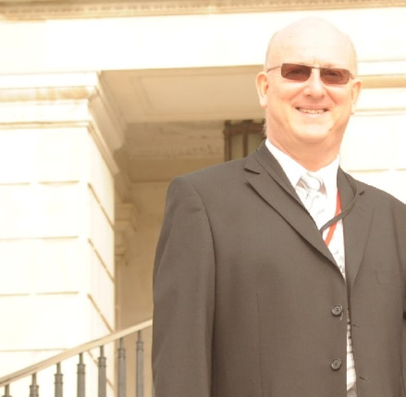
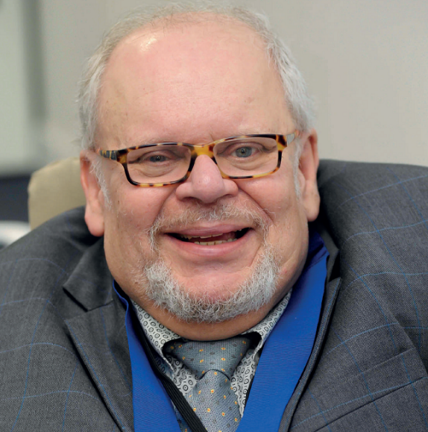
I realise it is the middle of the month, but there are two particular items of news that just cannot wait for the circulation of February's Members' Update.
It is with a sad heart that I must write about the passing of Colin Powell and Aidan Linton-Smith.
Colin Powell MBE
Colin was an active member of the British Polio Fellowship and as Patron, raised awareness of polio and Post-Polio Syndrome throughout the country. In fact, he received an MBE in the 2022 New Year Honours list for his services to people with polio in the UK.
Born Stewart Colin Powell, Colin was just 73 when he died on Tuesday 3 January. He will be greatly missed by the team, but even more by our very own, Dawn Grafetsberger. Dawn and Colin had become engaged late last year.
Colin worked tirelessly with Rotary to support the eradication of polio and with the Fellowship to raise awareness and generate funds for the charity. Last year he raised over £3,000 to go towards the Fellowship’s Heating Grant Fund which supports members on low incomes.
The funeral for Colin will be held on Tuesday, 24 January at 2:40pm at West Herts Crematorium, WD25 0JS
Aidan Linton-Smith
Aidan joined the Fellowship in 1979 and during that time supported the charity by holding key positions as National Treasurer and Trustee (2004-2014 and 2016-2022). More locally, he was Treasurer of the Inner London Branch and Chairman of the Home Counties North Region.
Aged 65, Aidan died of cancer on Thursday 5 January.
Many of you will recall his ongoing success at the National Indoor Games, where he was unbeatable as the Boccia Champion. Boccia was a real passion for Aidan and in 2012 he was recruited as a Games Maker for Boccia at the London Paralympic Games.
No funeral details have yet been announced. ”
A number of our members have been poorly over the Christmas period, many on antibiotics. It has been a tough time, but they are slowly making progress. Sheila S is now feeling much better after having to miss the Christmas meal and Anne R., Betty and Les have been hitting the antibiotics, but finally showing some signs of improvement. Our secretary Pat M has likewise been on the meds but, and this is a major announcement, actually had someone from her surgery visit her at home. Quite an achievement!
Many of you will remember Rose Cogbill, who had been coming along to our meetings, always with a cheery smile and greeting. Rose has been in hospital since before Christmas, firstly in RBH and currently in Windsor Ward of Wokingham Hospital, where she tells me she is going to the gym every day where the physios are getting her walking and increasing her strength. She is missing her little dog, Heidi, who is with a foster family. We have sent a card from the Branch and hope that she is soon more mobile.
We send our love and best wishes to all who need our thoughts and support at the moment.

On a brighter note, we have news of Berkshire Branch’s youngest member….

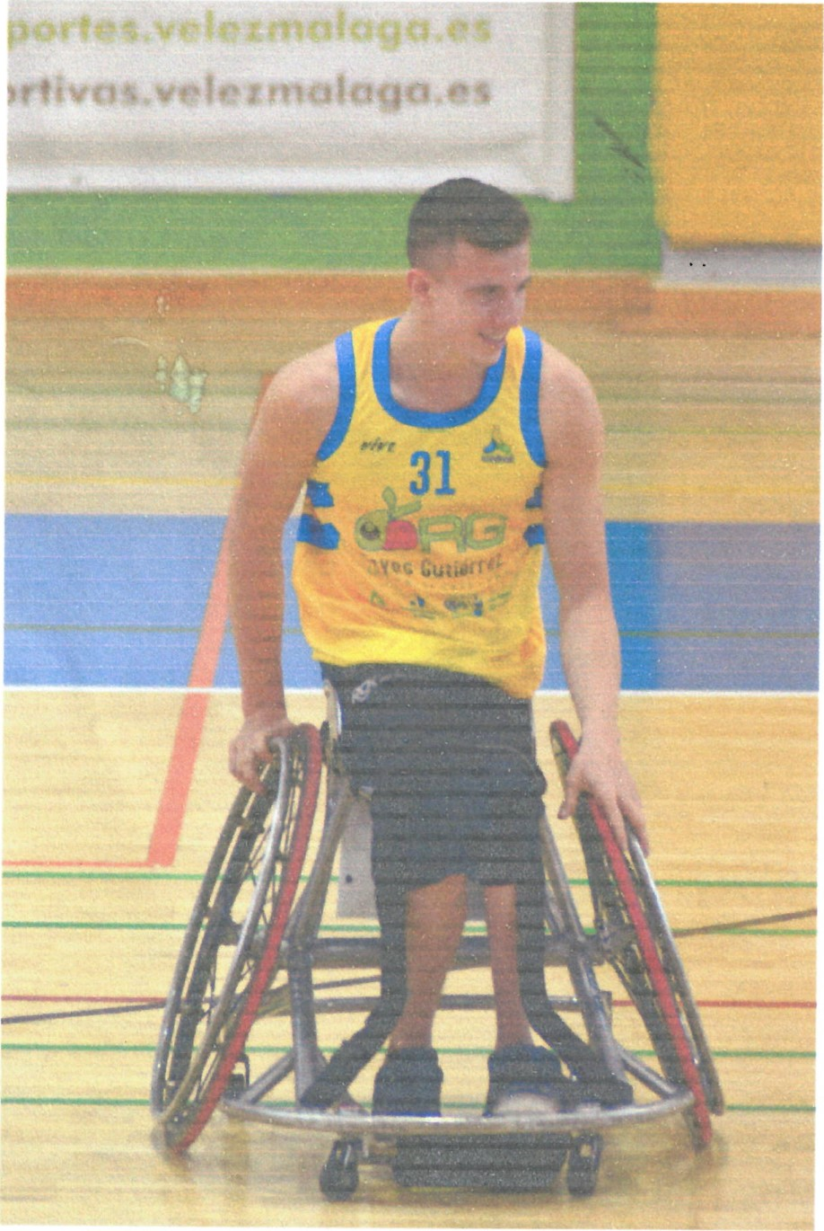
Peter Cusack, pictured, is now playing Wheelchair Basketball professionally and is shown here playing for his club, Amivef Reyes Gutierrez, in Malaga, Spain.
He has been training at camps with the GB squad this year and has been awarded lottery funding.
That’s great news and we really wish him well. It’s a full-on sport and highly competitive. Go, Peter, and thanks to Pat G for passing on the photo from Peter’s Mum, Nic.

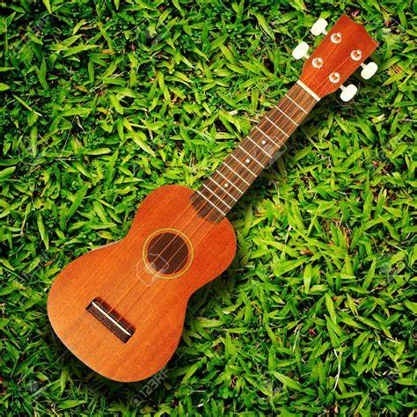
And, did you know???? Pat M has taken up playing the ukulele and, with a group of others, has performed her first gig!!! She shouldn’t have shared that, you know what we are going to be asking! Well done, Pat, Brett would be so chuffed!

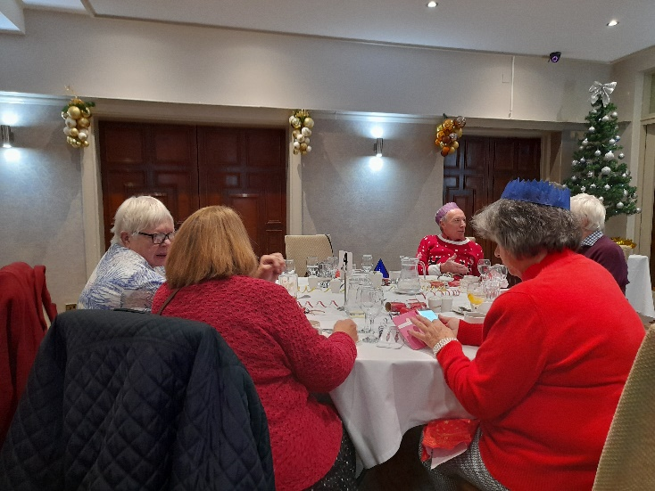
Christmas Lunch at the Lismoyne

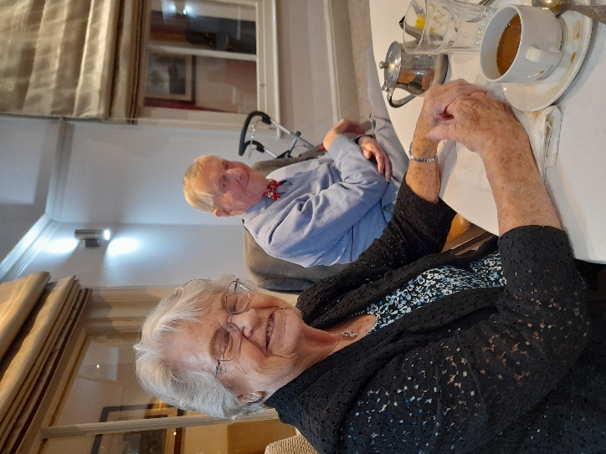

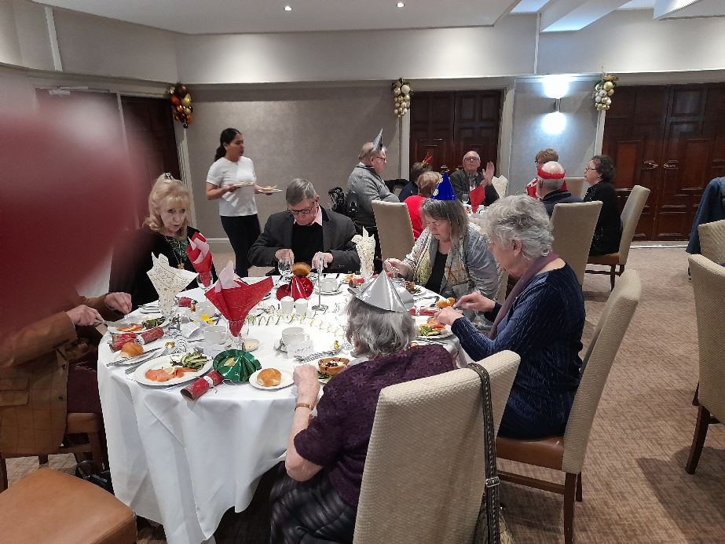

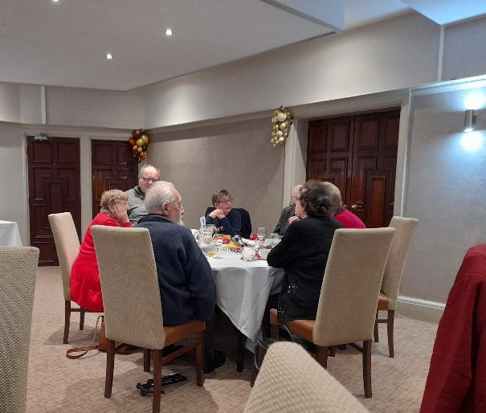
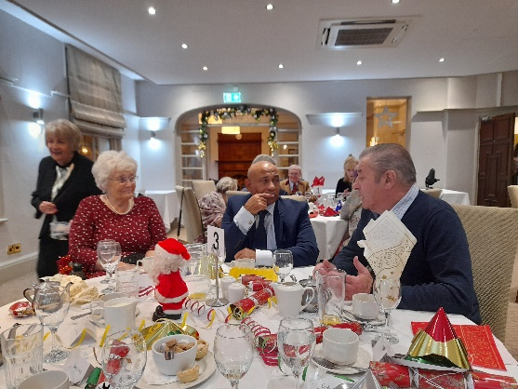
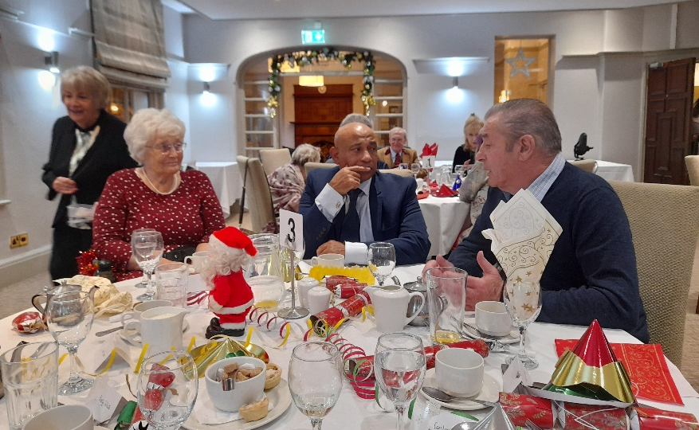
We had an enjoyable Christmas meal at the Lismoyne Hotel in Fleet. It was a great time together, good to see Leo with us. Apologies to Eric, but the idiot photographer had a finger in the way and blotted him out! Nothing personal, Eric.
So to 2023…..
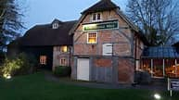
Having no meeting this month, our first gathering is, as notified, a pub lunch at Longbridge Mill, Sherfield on Loddon, Hook RG27 0DL on Saturday 11 February at 12 noon
We know that there is a bit of a walk even from Disabled Parking bays, so we shall have a manual chair there with us and will be happy to give anyone a push in to save the walk.
Please have a look at the menu and choose a starter and main or main and dessert. If you can send your choices to me as soon as possible, that would be great; the Bugle is later than planned as I had to get some issues fixed on my computer!!! Still a shame about the operator!
STARTERS
- TODAY’S SOUP (V)
Served with sourdough bread. Vegan option available. 394kcal
- CRISPY CAMEMBERT BITES (V) With apricot and ginger chutney. 348kcal
- DUO OF PÂTÉ* Duck parfait and ham hock pickled carrot & mustard terrine with red onion chutney and sourdough toast. 415kcal
- OVEN-BAKED BUTTON AND PARIS BROWN MUSHROOMS (V)In a garlic & Cheddar sauce with sourdough bread. 286kcal
- MAPLE-GLAZED CHICKEN WINGS Served with Asian style slaw. 620kcal
- SALT & PEPPER CALAMARI Served with saffron aioli & herbs. 298kcal
- KING PRAWN COCKTAIL* Avocado, tomatoes, Bloody Marie rose sauce and sourdough bread. 456kcal
- SLOW-ROASTED TOMATO ARANCINI (VE) With lightly spiced squash puree & basil pesto. 389kcal
MAINS
- HUNTER’S CHICKEN SCHNITZEL Topped with Cheddar and pancetta with smoky BBQ & tomato sauce and triple-cooked chips. 1573kcal
- FISH & CHIPS* Beer-battered cod with triple-cooked chips, mushy peas and tartare sauce. 1606kcal
- 8OZ GAMMON STEAK With free range eggs and triple-cooked chips. 980kcal
- CHICKEN & SMOKED PANCETTA PIE With spring onion mash, roasted carrots and green vegetables. 1209kcal
- SEARED FILLETS OF SEABASS* With pea & smoked pancetta veloute, broccoli and spring onion mash. 782kcal
- KEDGEREE FISHCAKES* With a poached egg, Tenderstem® broccoli, hollandaise sauce and fries. 877kcal
- PUY LENTIL, SAGE & RED WINE LASAGNE (VE) Served with a dressed mixed salad. 482kcal
- CHICKEN & VEGETABLE PENANG CURRY Pak choi, squash, red onions and peppers in a creamy coconut curry sauce served with jasmine rice 759kcal. Vegan option available 549kcal
- BEEF & CHIANTI CASSEROLE* With a Cheddar & herb cobbler, mashed potatoes, roasted carrots & Tenderstem® broccoli. 935kcal
- RICH BEEF & RED WINE LASAGNE* Served with garlic flatbread and a dressed side salad. 798kcal
- 8OZ SIRLOIN STEAK served with triple-cooked chips, homemade onion rings and a thyme-roasted tomato.940kcal
Burgers served with a choice of fries or triple-cooked chips.
- SIGNATURE BURGER Prime beef burger topped with spiked maple-glazed pulled beef brisket, streaky bacon, a Cheddar cheese sauce, red onion and mayo served with homemade onion rings. 1148kcal
- MOVING MOUNTAINS® BURGER (V) A plant-based burger with tomato, red onion, lettuce & burger relish 568kcal
Change your fries (v) 911kcal to a dressed side salad (ve) 600kcal, just ask!
Ideal for smaller appetites at lunchtime, available Monday - Saturday until 5pm. All sandwiches are served with fries.
- HOT BEEF BRISKET SANDWICH With beef dripping sauce and pickled pink onions on toasted sourdough. Served with fries. 1047kcal
- COD FISH FINGER SANDWICH* Beer-battered cod goujons and tartare sauce on a rustic roll. Served with fries. 908kcal
- COUNTRY CHICKEN SANDWICH Chicken breast, smoked Cheddar and smashed avocado with mustard on toasted sourdough. Served with fries. 816kcal
- SMOKY JACKFRUIT WRAP (V) Roasted red peppers, lettuce and slaw in a beetroot & chia seed wrap. Served with fries. Vegan option available. 531kcal
- STEAK FRITES 7oz Rump steak with fries. 763kcal
- LAMB SHEPHERD'S PIE* Topped with cheesy mashed potato. 569kcal

DESSERTS
- DOUBLE CHOCOLATE BROWNIE* (V) With Irish Liqueur Ice cream. 453kcal
- RICH BANOFFEE PIE (V) Topped with toffee fudge, cream and fresh caramelised banana slices. 759kcal
- STICKY TOFFEE PUDDING (V) Sticky toffee and date sponge, topped with salted butterscotch sauce and custard. 346kcal
- BAKED VANILLA CHEESECAKE (V) With a shortbread biscuit base, served with Herefordshire blackcurrants in sauce. 415kcal
- THE BLACK FOREST FLOWERPOT* (V) A chocolate flowerpot filled with a dark chocolate mousse, cherries in kirsch, brownie pieces and whipped cream. 698kcal
- BRAMLEY APPLE, BLACKCURRANT & CHERRY CRUMBLE (V) With vanilla custard. Vegan option available with soya custard. 659kcal
- VANILLA CRÈME BRULEE (V) With home-baked shortbread biscuits. 488kcal
- NAPOLITANO DELICE Belgian chocolate truffle mousse, vanilla custard and strawberry cream mousse layered on chocolate sponge with rich chocolate sauce & vanilla ice cream. 464kcal
- TRIO OF ICE CREAM
See below for options and calories.

APPLE SORBET (VE) 139kcal VANILLA POD ICE CREAM (V) 242kcal

BLACKCURRANT SORBET (V) 123kcal IRISH LIQUEUR ICE CREAM* (V) 263kcal

COCONUT MILK SORBET (VE) 223kcal RASPBERRY SORBET (VE) 157kcal

IRISH LIQUEUR ICE CREAM* (V) 263kcal

DOUBLE CHOCOLATE ICE CREAM (V) 311kcal £10 per Polio and £10 Carers
Saturday 25 March 12.30 - Calcot Centre Highview, Calcot, Reading RG31 4XD AGM and Fish and Chip

Please join us for this year’s AGM. You will receive all the requisite paperwork in due course and information about putting yourself or someone else forward for joining the committee.

We shall organise fish and chips for just before 1 o’clock and move into the meeting after that.

There will be further information on this year’s activities in the March Bugle. Please send us any ideas and suggestions you have for activities/trips. I have been in contact with Buckingham Palace, but they were not taking bookings until January, so, to help move on with that and aid planning, please indicate if you are interested in going; we are looking at early September, possibly 9th. The BPF AGM is on 16th.

Current Committee
Chairman: David Leeks
Secretary: Patricia Murden
Treasurer: Dawn Cooper
Social Secretary: Sue Brown

Welfare Officer: Amanda Leeks Other Members: Brenda Howard, Ray Howard

BPF Membership
By way of a reminder, 2023 membership is now due and even if you decide not to make a donation, you still need to complete the form and send it to head office in order to ensure that you can benefit from BPF membership. Obviously BPF would welcome your donations, which will help make the changes outlined in the current Strategy document adopted at the AGM last September and ensure that things are properly in place to meet the needs of members. I have attached a form to this email; you can send it back to head office, or give them a call on 0800 043 1935.

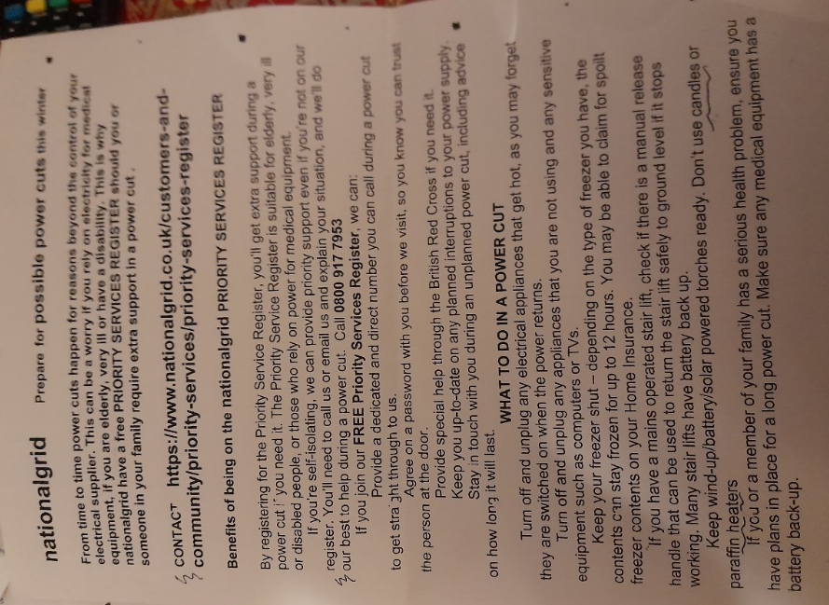
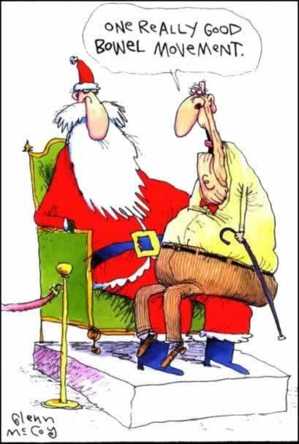
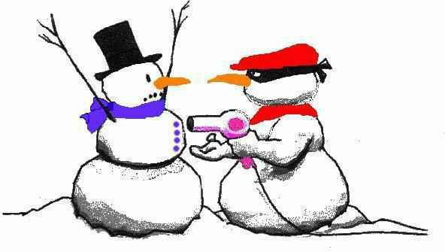

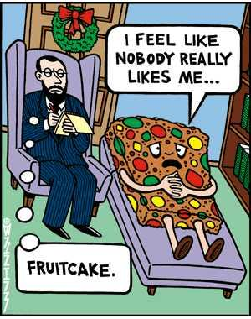
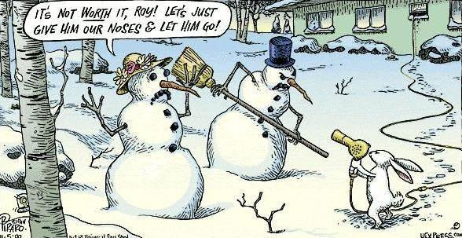
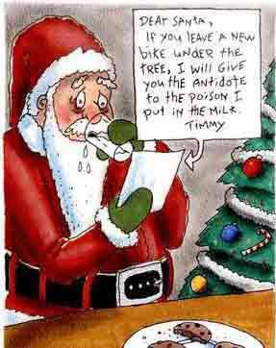

Social Diary – to return to Sue

Saturday 11 February – Pub lunch at Longbridge Mill

I/We would like to come Yes/No I/We require transport Yes/No

Menu Choices (starter and main or main and dessert)
Name ………………….. Name……………………….

……………………………………… ……………………………………..

……………………………………… ……………………………………..

25 March Calcot Centre Highview, Calcot, Reading RG31 4XD 12.30 Fish and Chips and AGM

I/We would like to come Yes/No I/We require transport Yes/No

We’ll assume fish and chips for everyone, but if you’d rather pie or sausage, please indicate below.

I / We would/would not be interested in the Buckingham Palace trip

YOUR NAME(S)

………………………………………………………………………………………………..

Please return asap to Sue Brown,

