NEXT MEETING 1pm Thursday 8th DECEMBER 2022 Cheshire, Wirral and North Wales branch at The Whitby Club, Ellesmere Port.
Report back on the branch annual dinner again Crabwall Manor Hotel & Spa
There were 11 of us gathered for our annual branch meal and food and service were fine and the company good but alas we were without our good friend and branch member Ian Davies who sadly passed away shortly after the branch visit to Jodrell Bank. Several members remain housebound but very much on the brighter side we were very pleased that the star of the Isle of Wight festival our very own Arty Davies thanks to his daughter for bringing him along.
Arthur was for quite some time in Warrington hospital and really didn’t get the physio support he needed and is struggling to get himself out of his wheelchair and on to his stool so he can wield the drumsticks once more. We heard that he is still keen to get a group together and capitalise on the publicity following the reality TV show Rock Till We Drop of which more below. Anyway, the good news is that Arty will be at the February 9th 2023 meeting and deliver the talk he had had to cancel in June 2022 when he broke his hip. His daughter is bringing him and fingers crossed we get to hear what wasn’t on the television show.

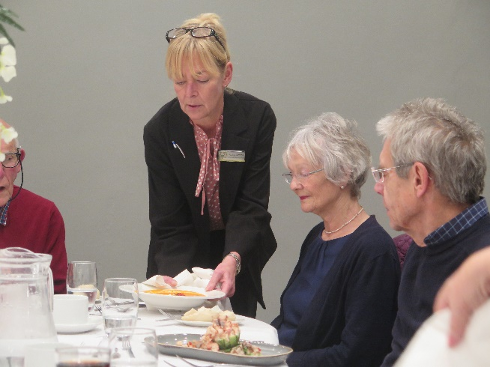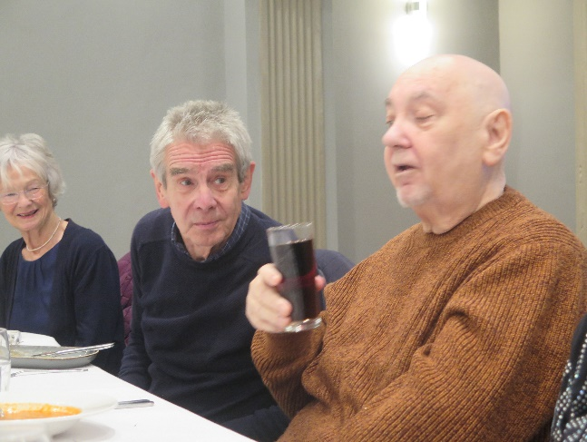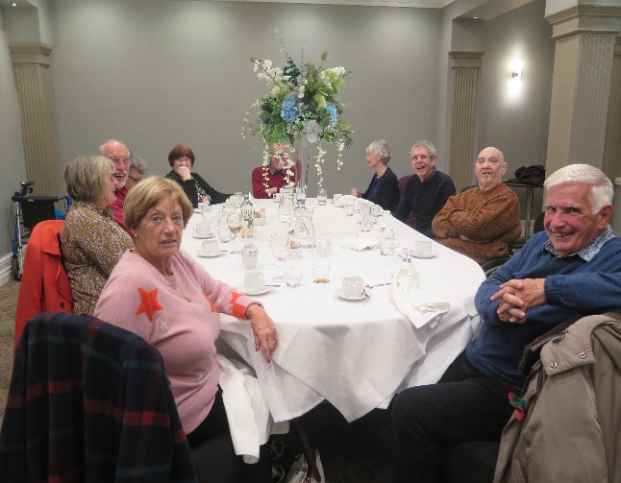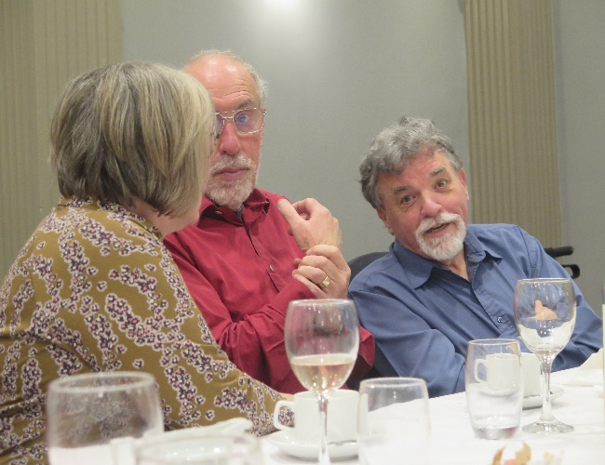

BRANCH CHARITY COLLECTION DAY FRIDAY 18th NOVEMBER
The staff at Tesco Superstore at Heswall were very kind and helpful and there was a steady flow of shoppers among which several stopped for chats on Polio with some having contracted the disease but no obvious disability and others who had relations who were infected. We pushed the Fellowship as much as possible and had a lovely little mini display at the collection point. We worked in two hour shifts and here we see Mandy, Dave,Bob and Lena.
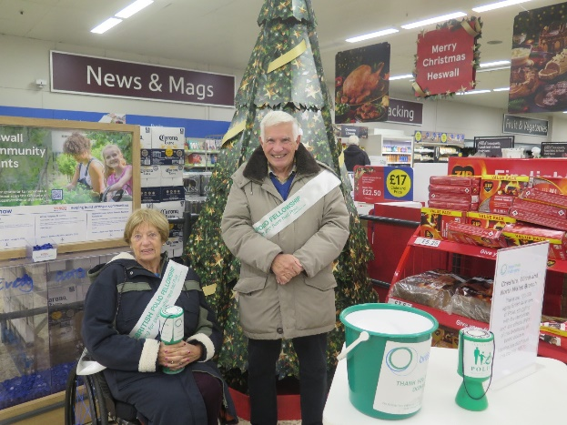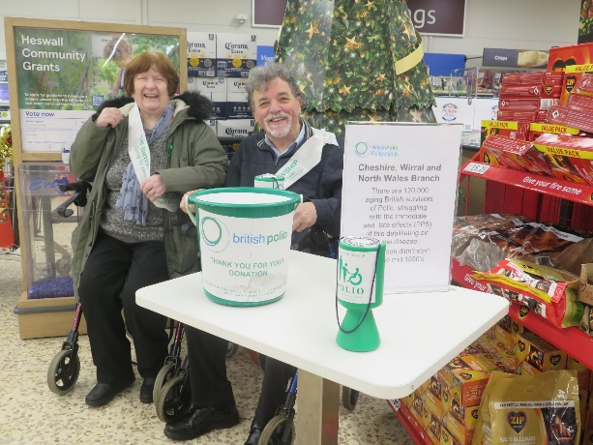

Just as we did for Arty’s planned June talk members are welcome to attend his talk in February, perhaps give us a ring before coming any great distance lest anything goes wrong. Here is a rerun of the article we prepared following the TV show.

Liverpool drummer Arty Davies finds fame at 73 on BBC’s Rock Till We Drop

After playing the drums for 55 years in a succession of bands, Arty Davies was resigned to being one of the Merseybeat era’s nearly men.

Arthur or Arty as he is known in the world of popular music is a member of the Cheshire, Wirral and North Wales branch of the BPF. Recently he achieved fame when he played at the Isle of Wight music festival. Arty is going to give a talk on his experiences making the show and perhaps some anecdotes which didn’t make the press. All BPF members of any region are welcome to come and meet Arty on 9th February 2023, 2pm at The Whitby Sports & Social Club, Dunkirk Lane, Chester Rd, Whitby, Ellesmere Port CH65 6QF
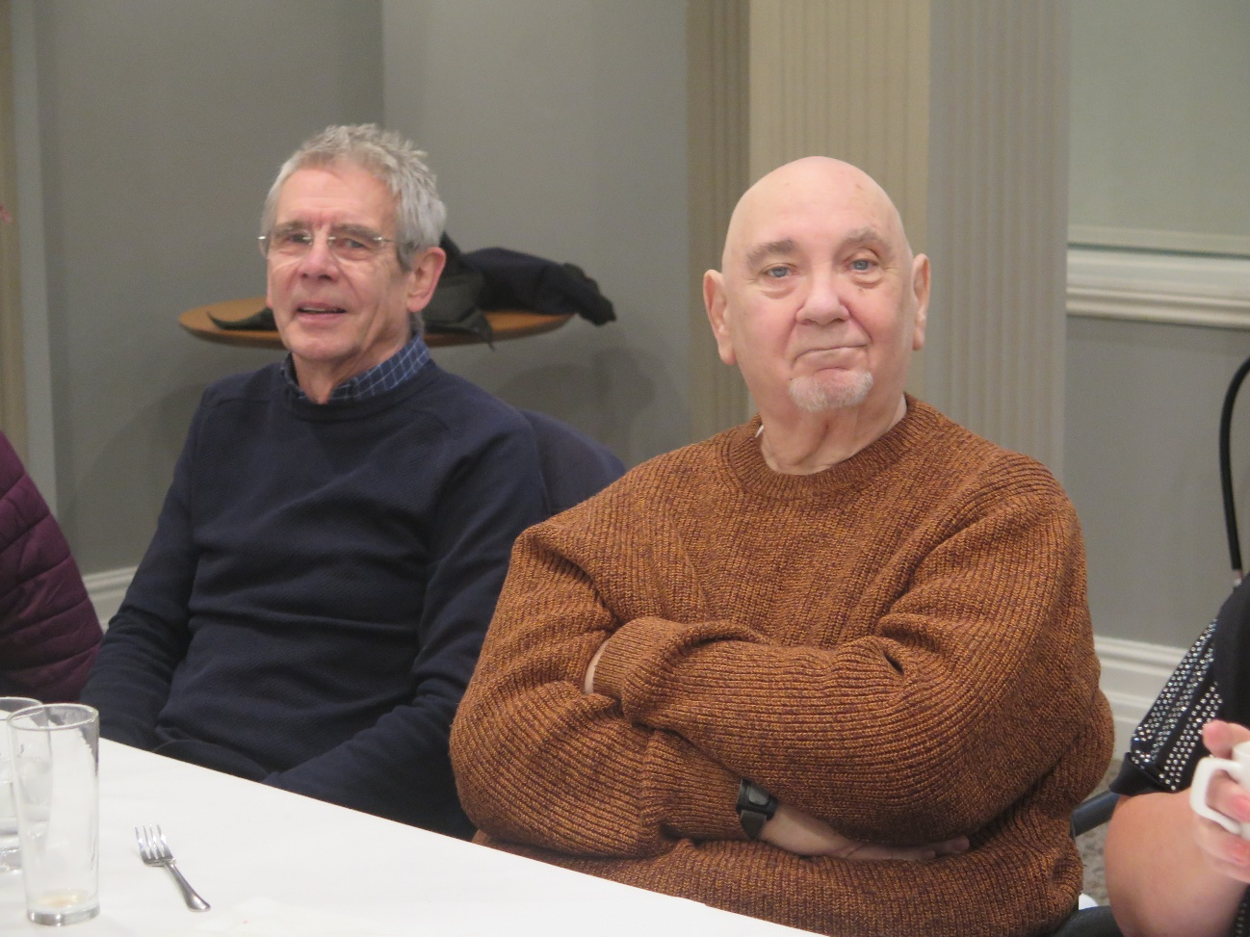
Arty with Chris at the branch dinner

The pandemic made him even more sure that a career which had spanned seven decades was almost certainly finished.
“I hadn’t touched the drums in two years because of lockdown, I didn’t even have the heart to get on the kit in the house, at my age I thought it was over for me,” he admits.
Arty could reflect on a busy life, hey was a Great Britain International at Wheelchair Basketball for over 40 years and competed in that sport and other sports, Swimming, Wheelchair Slalom, Wheelchair Tennis plus Wheelchair Racing, Shot-put, Discus. Javelin, Table tennis, Shooting, archery, sitting volleyball with a few Gold medals for them.
As well as playing drums with various bands. Fareons Flamingos, Lee Curtis and the All Stars, Four Just men, Kingsize Taylor and the Dominoes, Chris (Searcher)Curtis band, The Knight Crew etc. He also raised money for children’s charities as a member of musician charity bands, Merseycats & MerseyRats, Lanky Kats.
Despondent about the future he spotted an advert for a new BBC Two show, Rock Till We Drop, and everything changed.
The four-part series challenges Spandau Ballet’s Martin Kemp and MOBO award winning grime artist Lady Leshurr to form two rival bands, both made up of over 64-year-olds, to play the main stage of the Isle of Wight Festival.
“I did nothing about it when I first saw the ad then a friend of mine Carol from Manchester, who’s the lady bass player, sent me a message. I’d played in a band with her and she said, ‘you should do this Arty’ and sent me the form.
“I filled it in and sent videos of me playing with Faron’s Flamingo’s and another band, the TV company came back and said they liked what they’d seen. We did a video call – I had to ask my grandson to come round and set up Zoom for me – they sent a film crew to the house and I ended up down in London filming.”
For 73-year-old Arty, who was born in Garston but now lives in Runcorn, it was an opportunity that’s been a very long time coming.
He first picked up his sticks aged 17, after making an explosive entrance into the music world.
“I always wanted to be a drummer but I’m in a wheelchair from having polio at 18 months old and my mum and dad didn’t think I’d be able to play with my disability.
“A friend had just started a band and asked if I fancied playing bass. They went to Hessy’s shop and got me a Tuxedo bass and a Stanley amp, so I thought stardom was on the way – move over McCartney!
“On the day Liverpool beat Leeds in the FA Cup Final in 1965 the guitar nearly killed me. I was practicing and got a shock which threw me across the room. On the Monday morning we all went back to Hessy’s but Mr Hessy said we had a hire purchase agreement so he’d only exchange – I said ‘how about a set of drums, you don’t plug them in?’
“My mother gave me a look but she said ‘OK’. A friend came to show me a few things on the Wednesday and I did my first gig on the Saturday.”
Arty made his drumming debut at Garston Young Conservative Club, then went on to form his first band The Pressure Points. But when they broke up, he found the music business could be unkind to a lad with a disability.
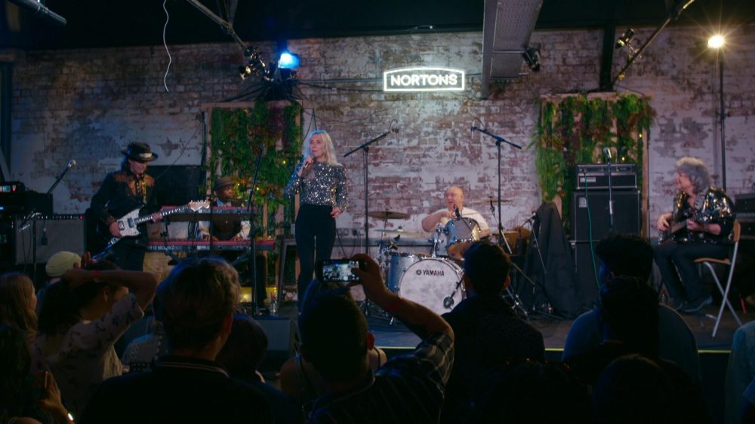
Arty Davies band on stage in Rock Til We Drop
“I couldn’t get into another band because of how I looked,” he recalls. “One band who came to audition me actually walked straight out and as they left they said, ‘we’re not having a cripple in our band’.”
Disillusioned, Arty started drinking heavily, until – after finding him drunk and asleep in the garden – his mum took him along to Liverpool Wheelchair Basketball training at Quarry Bank school.
“They put me in a chair and I couldn’t reach the net, but I still thought I’d go back again the next week and try. I ended up playing for Liverpool, for South London Acers, for Southport who were the best team in Europe then, and for Great Britain. I had a great time.”
Alongside day jobs, dad-of-five Arty carried on playing wheelchair basketball and drumming in various bands his whole life.
But, he says, he’s never known anything like the experience of being on Rock Till We Drop.
“It’s been so weird, seeing myself on telly, and I’ve definitely been getting some stick off my grandkids and my kids, and loads of people who saw me on the trailer for the show throwing my sticks in disgust.
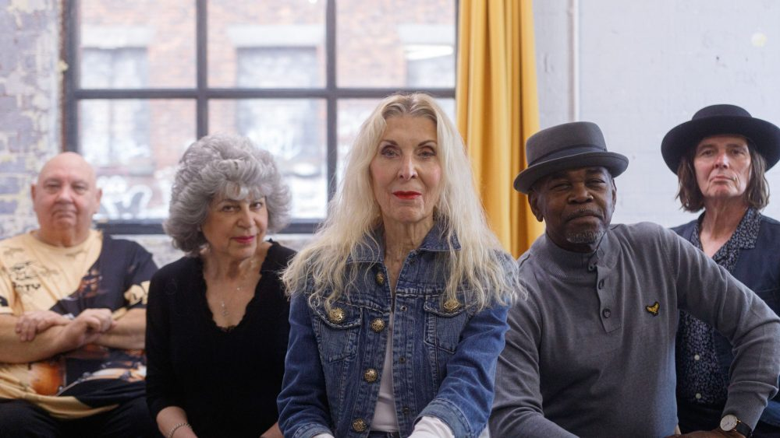
Arty, left, with fellow band members in Rock Til We Drop (Credit: Amelia Jones)
“Right up to the last day, I wasn’t going to go through with it and my son said, ‘go dad’ then Faron phoned me up and said, ‘get there, have the experience’, he was really pushing me to go, and I’m glad he did.
“At the Isle of Wight Festival, they said there was about 60,000 in the audience. After all these years, when I went out on stage and I just looked at them and thought, I’m having this!”
He said that initially his parents said he couldn’t play the drums because of his disability, but when someone in the park asked him if he fancied learning the bass guitar, his parents agreed and bought the instrument for him.
However, fate intervened in dramatic fashion as he suffered an electric shock practising with the band in a studio which “threw him across the room” and left him “shaking for days”.
They returned the bass to the shop and his parents acquiesced to the request for a set of drums, offering the obvious safety advantage of not needing electricity.
When his first band broke up, Arty suffered rejection in his bids to join other bands who with blunt prejudice turned him down due to his disability.
Arty retreated to his room in disappointment, leading to an intervention from his mother who came in and said ‘come on, put your coat on’ to coax him from his gloom and take him to a wheelchair basketball session at Quarry Bank High School, of John Lennon fame and where Arty’s determination prevailed over the initial challenge of his shots not reaching the net.
His confidence restored, he found himself back in a band and performing ‘60s music during a golden age, and which continued right through his life, he moved to Runcorn in Cheshire, 40 years ago, and has five children, eleven grandchildren and seven great grandchildren. His drumming days though were to be interrupted by Covid-19 and the privations of lockdown.
Again, opportunity knocked when a friend told him to apply for the Rock Till We Drop reality TV band competition show. Initial reluctance drifted away and Arty found himself applying and being accepted to appear in the show.

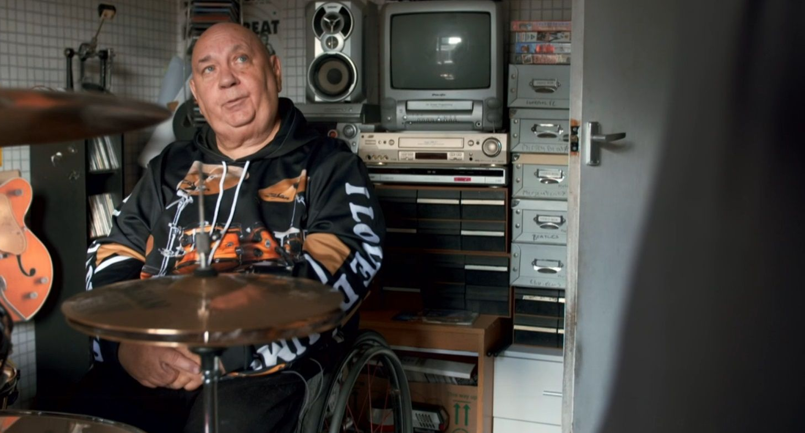

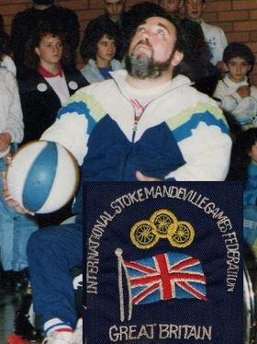

He then got together with his other new bandmates picked by their team leader and performed in rehearsals, on stage in Birmingham and Southampton as well as trips to London, and finally in September at the Isle Of Wight Festival, whose stage has been graced by some of the biggest names in music including the likes of Jimi Hendrix and The Rolling Stones.
While Arty’s Band of Strangers group was managed by rapper Lady Leshurr, lining up the rival act was Martin Kemp of Spandau Ballet fame.
Describing how he found himself back on stage for what he called the “biggest gig of my life”, Arty said: “They’d put an ad out for band members aged over 64.
“A friend got in touch and said ‘put in for it Arty’.
“I hadn’t played for two years due to Covid and I sent the form off and Sunday morning they said ‘we like your videos’ and the next thing I had a TV crew round my house.
“It all went so quick from there.”
He added: “On September 19 we played the Isle of Wight main stage.
“Duran Duran were on the same bill as us and Imelda May, it was very good to meet her.”
No reality TV show would be complete without some rocky waters along the way and Arty found himself providing some drama by throwing his sticks in the air in frustration at having to play a song he didn’t like - the track Red Red Wine.
He said: “They put me in a band doing reggae and I struggled with it.
“I was speaking to one of the musical directors on the phone and I said ‘cor blimey, I come out a right moaner’ - there’s one point where I throw my sticks in the air and say ‘get me home’.
“They said ‘if everyone had come in and it was hunky dory it would have been a boring programme'."
Arty and the band got to play two tracks at the Isle of Wight festival., which was “over too quick” for him.
On the moment it came for Arty to perform, he said: “It was funny, people were saying ‘were you nervous?’
“I was pushed out onto that stage and thought ‘I’m having this’ - no nerves at all.”
The performance has earned Arty a new fanbase, some of them far from home.
He said: “A lot of people have been interested in the show on Twitter and Instagram took off with it all.
“It’s just unbelievable, just people loving it with the comments.
“I got a message from a lady in Australia loving the show, and a fella in America who we’ve sent a link so he can watch the shows."

